Account Manager project follows the MVC architectural framework. It consists of model, view, and controller packages. AccountList loads Account’s from a file. Account supports withdraw and balance behavior. Agent’s continuously withdraw or deposit funds to showcase concurrency via threads in Java.

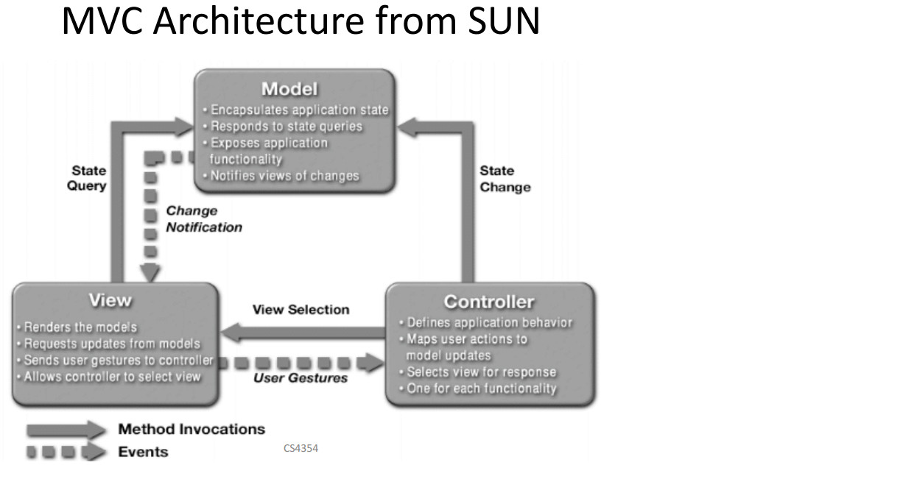

- Credit: Sun